

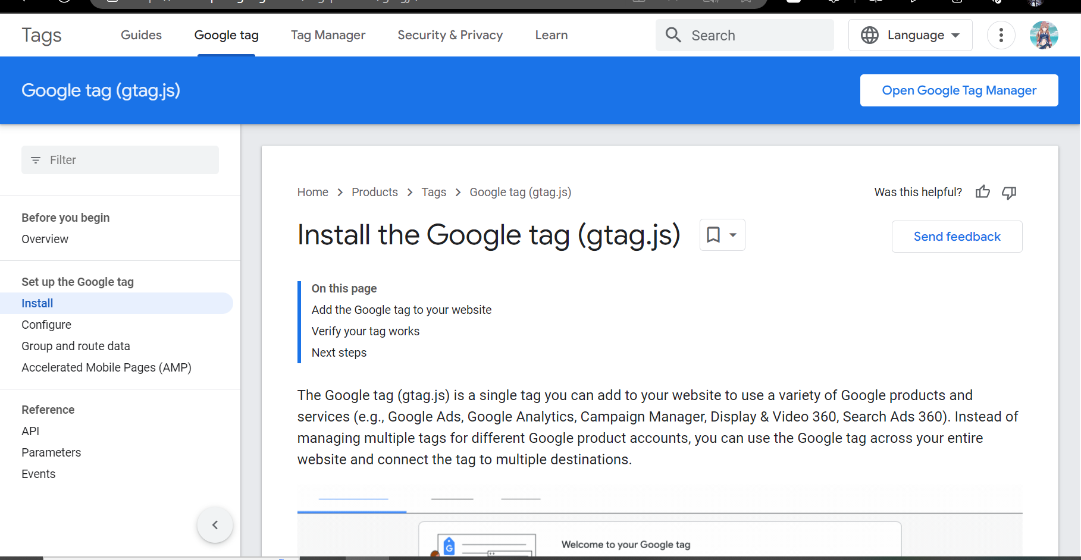





When I was doing this I wanted it to the header to be an .svg but I couldn’t get it to work properly to I had to scrap it and move on to a different Idea so I used an .png picture as my heard picture and that worked better but if I was to do it differently id go back and figure out to do the svg properly

